INVESTIGATION – Area of a Triangle
Objectives for the next two lessons:
- Know the standard labelling of a triangle
- Derive a formula for the area of any triangle given two sides and the angle between them
- Practice finding the area of non-right triangles

- This is how the sides and angles of a non-right triangle are labelled conventionally:
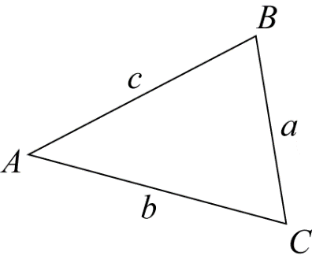
Write two statements describing the pattern of the A's and b's etc when a triangle is labelled in this way.
Statement 1:

Statement 2:

- Label this triangle:

Write an expression for the area of this triangle:

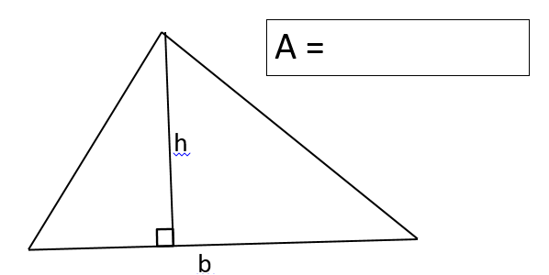
A =
- Using your knowledge of right-angled trigonometry in triangle on the left, write an expression for h:
h =
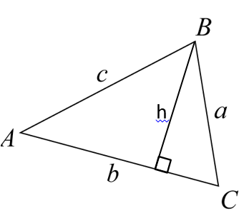

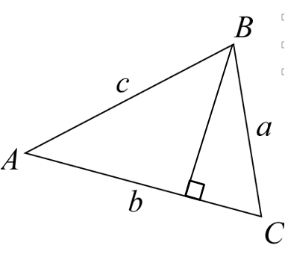
- Using your expression for h developed above, write an expression for the area of this triangle:
A =

- By considering the other two possible heights of this triangle, write two other expressions for the area of this triangle.
A₂ =

A₃ =
- Now write one big equation that shows that each of the three expressions for the area of the triangle is equal to each of the others:
A₁ | = | A₂ | = | A₃
 | = |  | =

