Abu Dhabi Education Council |  | مجلس أبو ظبي للتعليم
Aisha Bint Abi Baker Secondary School |  | مدرسة عائشة بنت ابي بكر للتعليم الثانوي

- The frequency histogram is a _____ graph.
picture
column
line
divided bar

- The cumulative frequency for a score of 13 is .

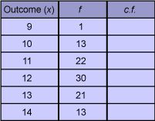

- Match the measures on the left with their meaning.

range |  |  | spread of scores
mode |  |  | middle score
median |  |  | outcome that occurs the most
mean |  |  | arithmetic average

- The greek letter Σ can be used to indicate __________.

the mean
the median
the sum of
the distribution

- Find the range, mode, median and mean of this set of scores: 15, 36, 40, 23, 18, 46, 21, 28, 32, 36.

range |  |  | 30
mode |  |  | 29·5
median |  |  | 36
mean |  |  | 31

- Use your calculator to evaluate the mean of this set of scores (to 2 decimal places).
23, 26, 24, 31, 29, 36.
25, 28, 32, 35, 23, 37.
24, 39, 21, 26, 32, 29.

28·89
31·20
28·88
30·84

- Use the table below to help you match each item on the left with its answer on the right.
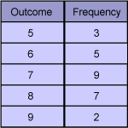

the total number of events which occurred |  |  | 6
the score which had a frequency of 5 |  |  | 26
the mean for this data |  |  | 7
the range |  |  | 4

- A set of scores may have more than one _____.
range
mode
mean
median

- Match each class to its class centre.

29–37 |  |  | 34
36–40 |  |  | 33
30–40 |  |  | 35
31–37 |  |  | 38

- Match each item on the left with its value on the right.
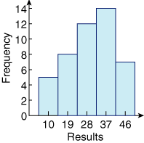
median class |  |  | 37
the frequency of the class with centre 10 |  |  | 28
the modal class |  |  | 5

