- This is the graph of y = x² – 3x – 2.
On the same grid, plot the line y = 3x – 7.
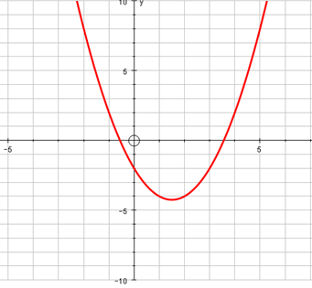
Find the coordinates of the points where these two graphs intersect:
( , ) and ( , )
Use the points to solve the simultaneous equations
y = x² – 3x – 2
y = 3x – 7
x = ________ and y= ________
or
x = ________ and y= ________
- This is the graph of y = 2x² – 6x – 5.
  - Use it to solve the equation 2x² – 6x – 5 = 3.
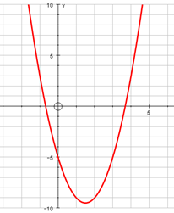
  - By adding another line, solve the simultaneous equations
y = 2x² – 6x – 5
y = -2x + 1
x = ________ and y= ________
or
x = ________ and y= ________

