What Surrounds Life
A scientist who has been doing nothing but research’s for the past 5 years. is a girl who became 22 years old this year. She always had an interest on arithmetic; you could say that it was her gift. Since she was young, during her childhood times, she was considered as a very unique and brilliant student, who understood and solved questions that weren’t even suitable for kids her age. Because of that she entered university early and opened her own research lab in an early age of 17.
One day her friends thought of getting herself outside, it didn’t matter where but that she should take a breather once in a while. The reason they decided this now and not during the 5 years she locked herself in was because, whenever and wherever she goes, this scientist would never ever stop thinking about math. If it’s not thinking then she would mumble: “1999823…..+265466….897…..” it was kind of irritating, so they left her alone, but this won’t happen now!
The scientist always took calculator, compass, counting board, graph paper, protractor…..and many other things with her around, but this time they wouldn’t allow her to take one. They grabbed all of her math related tools and hid them somewhere. If she truly likes them then she would go try finding them. By doing so, it might make her stay outside for 5-6 hours searching for them.
The thing is, they weren’t inside the town when the hid the tools but they were in a place far away from the town. They did that thinking that this will make it hard for her to go back to her research laboratory.
All of them, the scientist and her friends were in a place that looked a like a forest. This forest didn’t have any vicious animals so they were safe. They chose this place as a destination to keep their dear friend scientist in a place she wasn’t really familiar with. Anyhow the scientist started searching for her special tools.
She unsurprisingly found her compass and measurement tools stuck on a branch of a tree. “If I could find these two this fast then everything else will be very easy!” she thought. Unexpectedly it came out true. She found mostly everything in mere 2 hours, but there was a problem she faced. She went all over the forest looking for her tools but only found 75% of her tools. She thought and thought…”where would they put my tools?” She continued walking around thinking that she might’ve passed some place that had her tools hanging around. She suddenly slips, and *Crash* she falls!

………”where am I?” she asked while slowly opening her eyes. Everything was pitch black. She took out a flashlight she had in her bag, and she lights it up, she saw herself surrounded with rocks. “Did I fall in a hole?” She asked herself. She stood up and took out everything from her bag, thinking of a plan way out.
First she tries calling her friends but during the fall her phone broke so she couldn’t use it. Most people would panic and would think that “it’s over” but for this scientist she thought of using everything she learnt how to read, she should use it in this moment of her life. The air began to suffocate her so she quickly took out her drawing tools and drew the hole she was in
The Hole
She started measuring the ground first and it was 10m wide. Since the hole looked triangle shaped she assumed that the angle would be 52° and 95° degrees.
The Hole
10m
52°
95°

The reason she is doing all of this is because she wants to
know the height of this hole. The scientist already had a
rope with her, but it was kind of short. So she wants to
understand just how long this rope should be so she could
climb out. Despite the suffocating air that is consuming
her, her mind became filled with math once she just starts
doing anything related to it.
The scientist began to use her calculator, she inserts
{10 ÷ cos(95) }. She used (cos) because she wants to find out about
the hypotenuse (height). she already has the adjacent (wide) which
is 10m so she divides 10 by cos(95) and it equals = 13.69m
Now that she knows the wide she understands just how tall the rope should be so that she could get out.
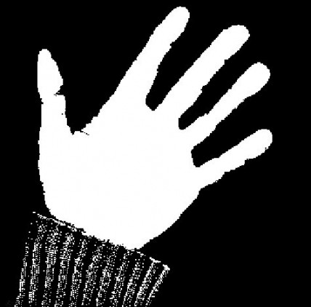
She finally gets out from the hole with her face all red! But thought that there will not be a second time where she would be in a life and death crisis (because of the heavy air that was surrounding her) so she used this as a valuable lesson and told her friends….. “MATH RULES!!
The End

